Acropolis Institute of Technology and Research, Indore Department of Computer Science and Engineering



B. Tech. VI Semester JAN-JUNE 2024

**DATA ANALYTICS LAB REPORT**

CS-605

Submitted To: Submitted By:

Prof. Anurag Punde Harsh Tiwari

0827CS211093

Table of Contents

Dashboards

|  |  |  |  |  |
| --- | --- | --- | --- | --- |
| **S. No.** | **Date of Experiment** | **Experiment** | **Date of Submission** | **Signature** |
| 1.1 |  | Cookie Data Dashboard |  |  |
| 1.2 |  | Supermarket Dashboard |  |  |
| 1.3 |  | Store Data Dashboard |  |  |
| 1.4 |  | Car Collection Dashboard |  |  |
| 1.5 |  | Order Data Dashboard |  |  |
| 1.6 |  | Loan Data Dashboard |  |  |
| 1.7 |  | Shop Sales Data Dashboard |  |  |
| 1.8 |  | Sales Data Dashboard |  |  |

Reports

|  |  |  |  |  |
| --- | --- | --- | --- | --- |
| **S. No.** | **Date of Experiment** | **Experiment** | **Date of Submission** | **Signature** |
| 2.1 |  | Cookie Data Report |  |  |
| 2.2 |  | Supermarket Report |  |  |
| 2.3 |  | Store Data Report |  |  |
| 2.4 |  | Car Collection Report |  |  |
| 2.5 |  | Order Data Report |  |  |
| 2.6 |  | Loan Data Report |  |  |
| 2.7 |  | Shop Sales Data Report |  |  |
| 2.8 |  | Sales Data Sample Report |  |  |

**Dashboard For Cookie Data**

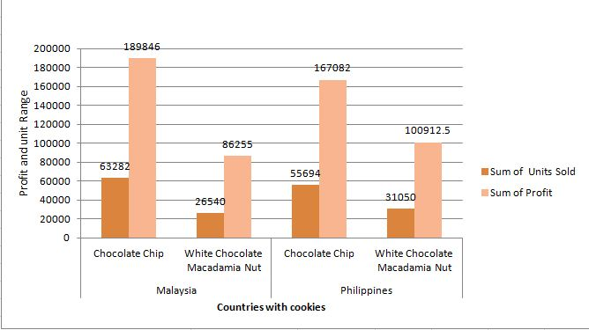 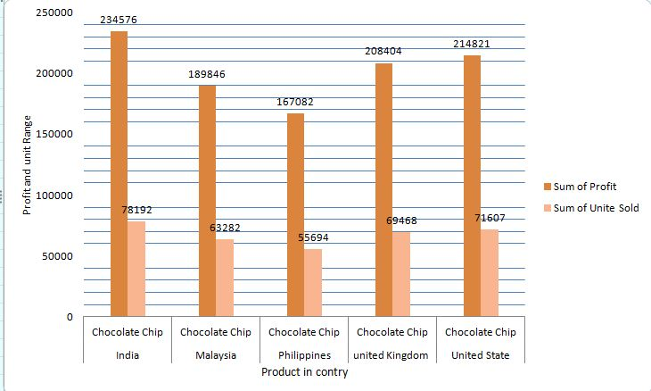

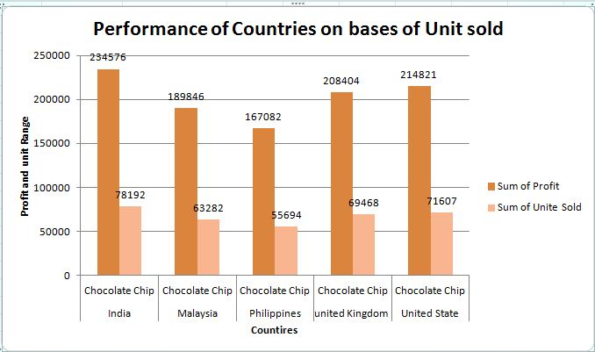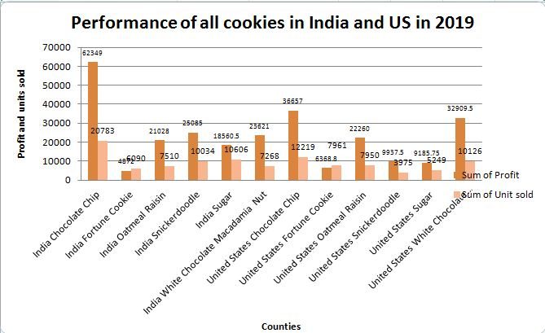

**Dashboard For Super Market Data Analysis**

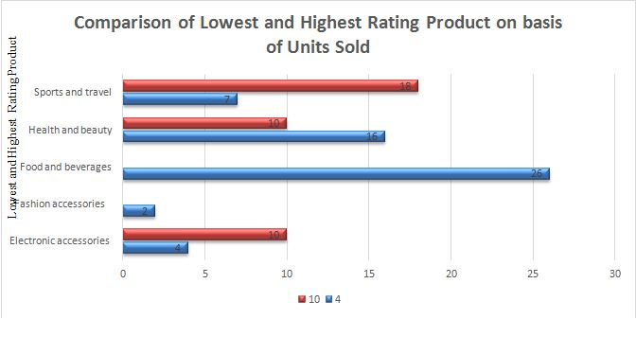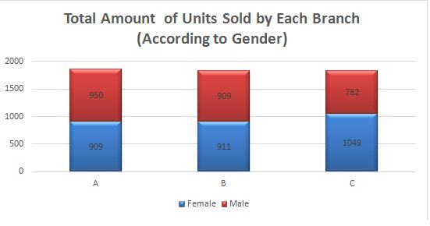

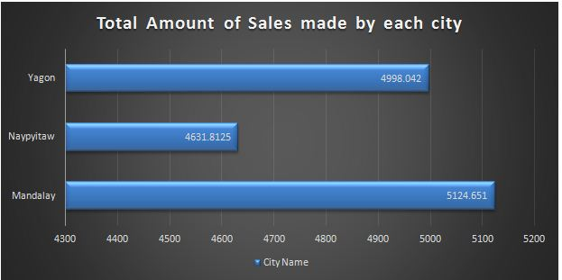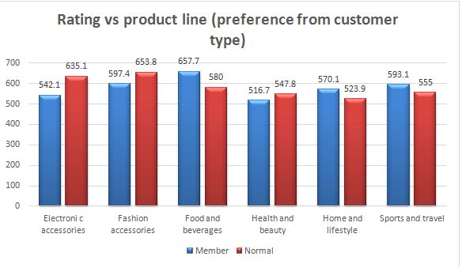

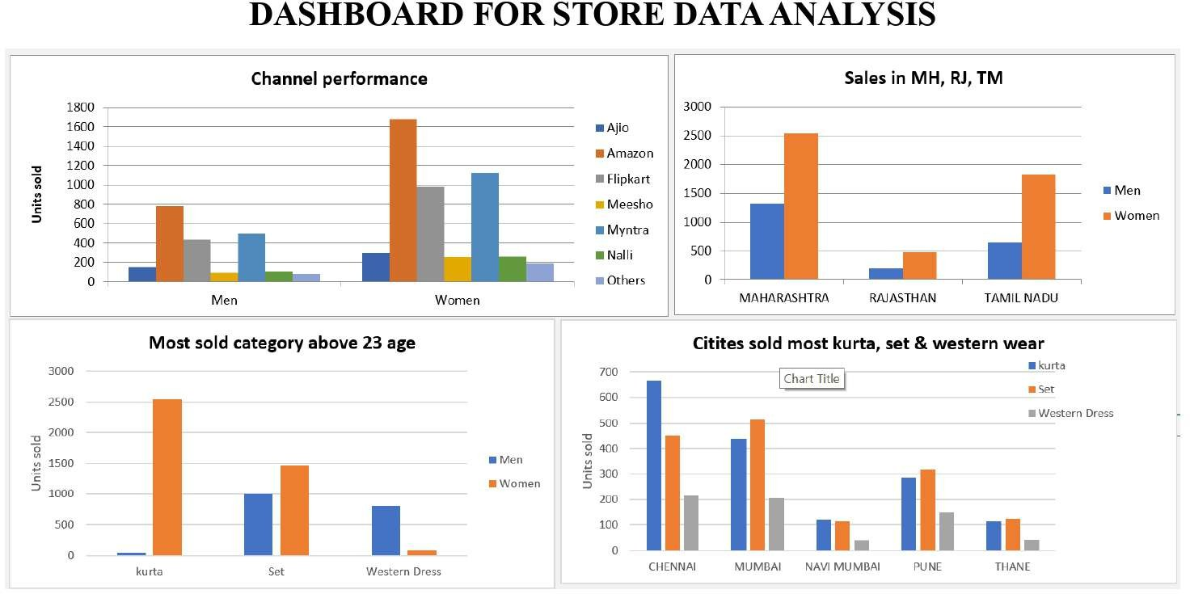

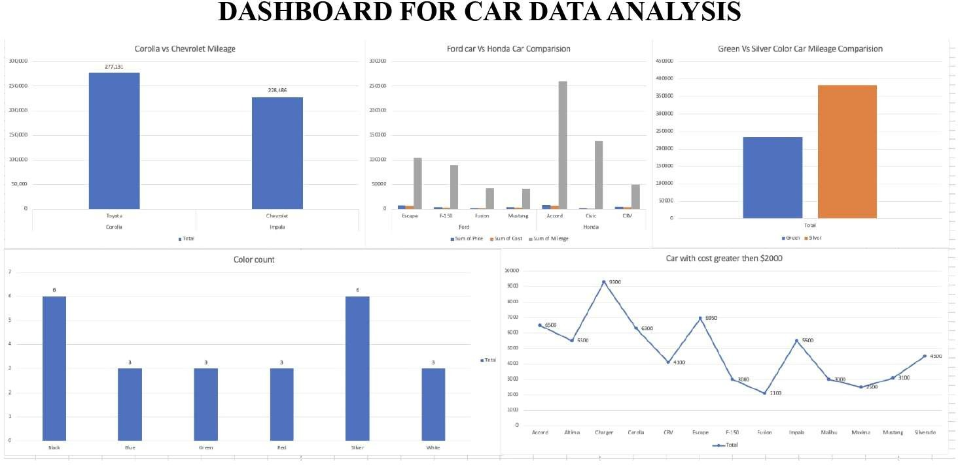

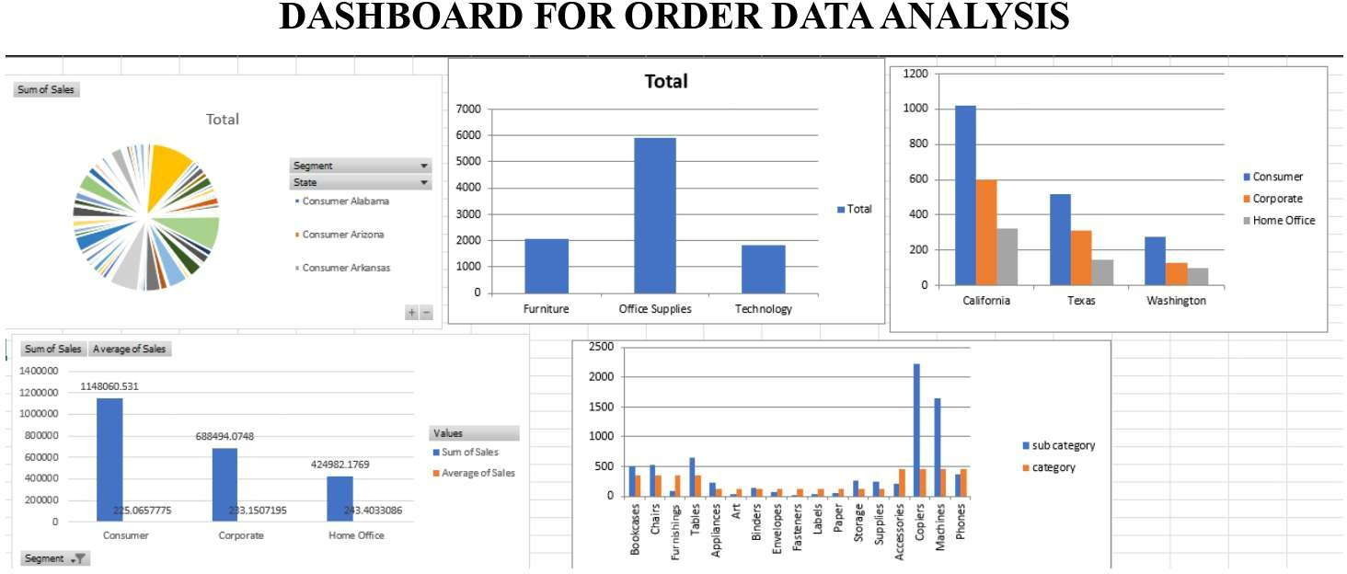

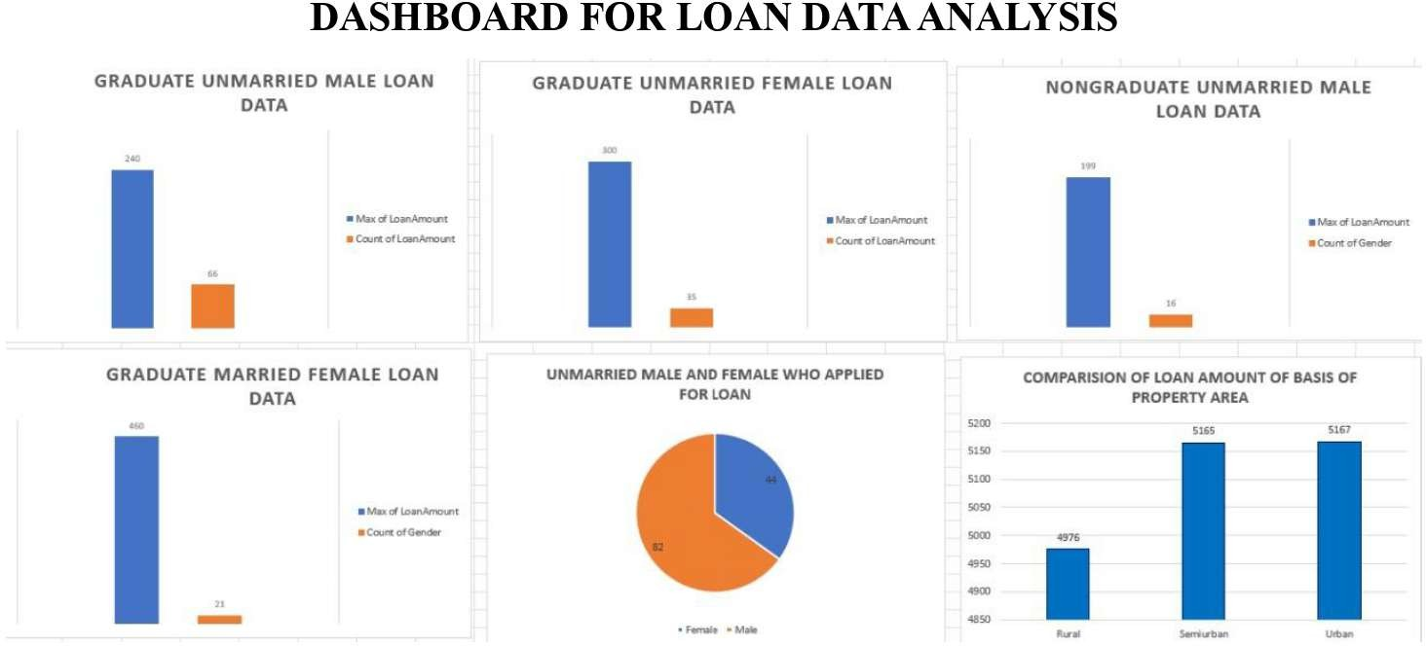

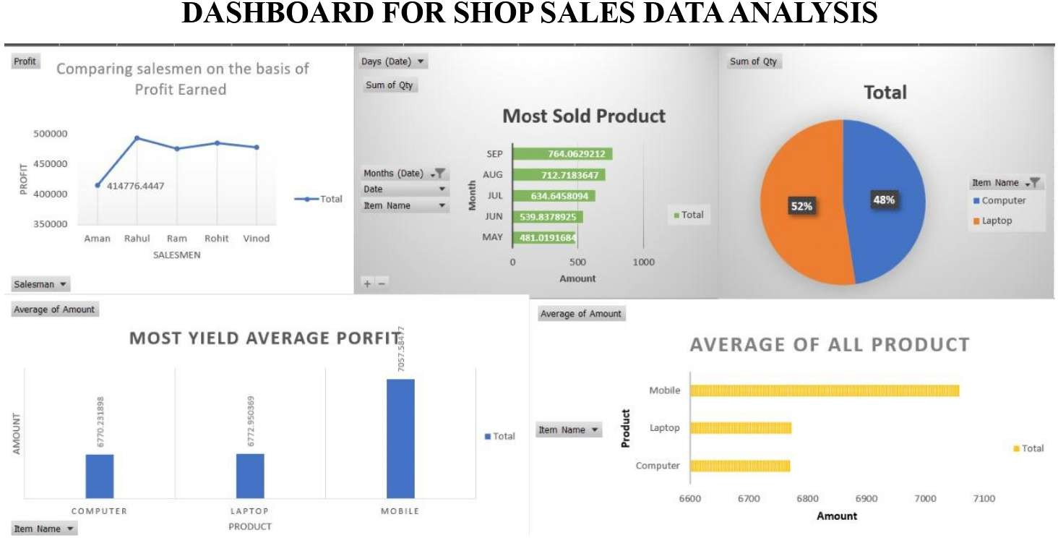

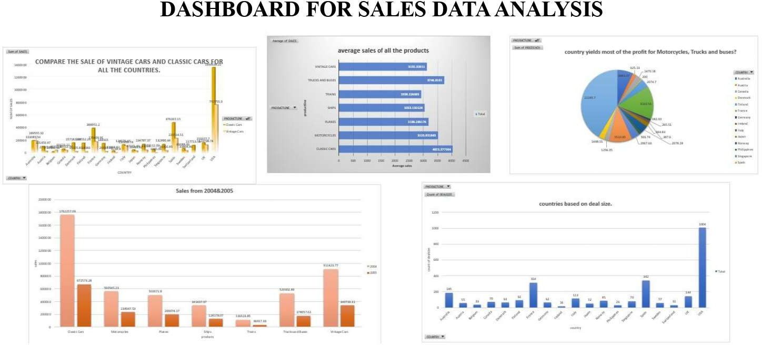

Introduction:

# Cookie Data Report

In our cookie data set cookies—specifically six types: Chocolate Chip, Fortune Cookie, Sugar, oatmeal Raisin, Snicker doodle, and White chocolate macadamia Nut.

We've got a treasure trove of data on these cookies, covering how many units were sold, their costs, the money they brought in (revenue), and the profits they made. And we're not just looking at one place or time; we're exploring different countries and dates to see how things vary.

This report isn't just about cookies; it's about understanding what people like, how much they're willing to pay, and where these treats are most popular. So, get ready to uncover some fascinating insights into the cookie world and what it means for businesses like yours.

## Questionaries :

1 . Compare Malaysia and Philippines on the bases of two types of Cookies

1. What is the performance of Choco Chips Cookies in all Country Which Competes the best.
2. Compare all the countries on the bases of profit and unit sold, which is the best performance country on the basis of profit.
3. which Cookie is the best Selling Cookie in India and US in year 2019,

## Analytics :

(1) Compare Malaysia and Philippines on the bases of two types of Cookies.

Ans:-The comparsion of Malaysia and Philippines on bases of Chocolate chip and White Chocolate Macadmia nut is given below:-



1. What is the performance of Choco Chips Cookies in all Country Which Competes the best.

Ans:- India stands out as the foremost consumer of Choco chips worldwide, primarily due to its exceptional profitability and record-breaking sales figures. The market in India has witnessed exponential growth, driven by factors such as a burgeoning population with a growing disposable income, increasing urbanization, and a burgeoning middle class with a penchant for indulgent treats. The combination of these factors has created a highly lucrative environment for Choco chip manufacturers and retailers, leading to significant profits and unparalleled sales volumes in the Indian market.

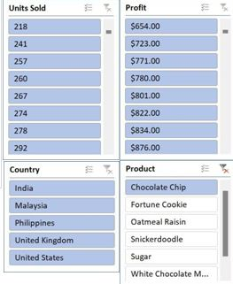 (2)Compare all the countries on the bases of profit and unit sold, which is the best performance country on the basis of profit.

Ans:- India stands out as the leading performer globally when it comes to both profit generation and units sold in the Choco chip market.

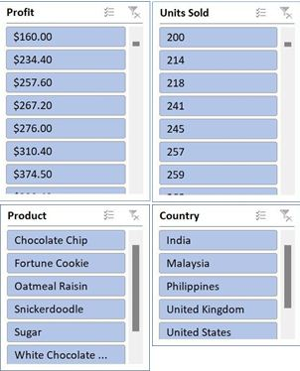

(4) .which Cookie is the best Selling Cookie in India and US in year 2019,

Ans:- In the year 2019, chocolate chip cookies emerged as the top-selling cookie in both India and the United States.



## Conclusion and Review:

After thorough analysis of the cookie sales data, it is evident that there are notable trends and insights to be gleaned. By examining key metrics such as units sold, revenue, cost, and profit across different countries and products, we can draw valuable conclusions about market demand, pricing strategies, and overall profitability. This comprehensive understanding will enable informed decision-making to optimize resources, target specific markets, and maximize profits in future cookie sales endeavors.

#### Regression:

The regression model, with a significant p-value (p < 0.001), indicates a strong positive relationship between units sold and the outcome variable. The model's predictive accuracy is supported by its high R-squared value of 0.688, suggesting that approximately 68.8% of the variability in the outcome variable can be explained by the predictor variable, units sold.

|  |  |  |  |  |  |  |  |  |
| --- | --- | --- | --- | --- | --- | --- | --- | --- |
| SUMMARY OUTPUT | | | | | | | | |
| *Regression Statistics* | | | | | | | | |
| Multiple R | 0.829304 |  |  |  |  |  |  |  |
| R Square | 0.687746 |  |  |  |  |  |  |  |
| Adjusted R  Square | 0.687298 |  |  |  |  |  |  |  |
| Standard  Error | 1462.76 |  |  |  |  |  |  |  |
| Observations | 700 |  |  |  |  |  |  |  |
| ANOVA | | | | | | |  |  |
|  | *df* | *SS* | *MS* | *F* | *Significance*  *F* |  |  |  |
| Regression | 1 | 3.29E+09 | 3.29E+09 | 1537.356 | 1.4E-178 |  |  |  |
| Residual | 698 | 1.49E+09 | 2139668 |  |  |  |  |  |
| Total | 699 | 4.78E+09 |  |  |  |  |  |  |
|  |  |  |  |  |  |  |  |  |
|  | *Coefficients* | *Standard*  *Error* | *t Stat* | *P-value* | *Lower 95%* | *Upper*  *95%* | *Lower*  *95.0%* | *Upper*  *95.0%* |
| Intercept | -74.4103 | 116.5304 | -0.63855 | 0.523326 | -303.202 | 154.3817 | -303.202 | 154.3817 |
| Units Sold | 2.500792 | 0.063781 | 39.20914 | 1.4E-178 | 2.375567 | 2.626017 | 2.375567 | 2.626017 |

#### Co-relation:

The correlation coefficient between units sold and revenue is 0.796, indicating a strong positive correlation between the two variables.

|  |  |  |
| --- | --- | --- |
|  | *Units*  *Sold* | *Revenue* |
| Units  Sold | 1 | 0.796298 |
| Revenue | 0.796298 | 1 |

#### Anova (Single Factor) :

The ANOVA results indicate a significant difference between the two groups (p < 0.001), with 1 degree of freedom. The within-group error is 7681356717, and the total R-squared value is 0.06, suggesting that the model explains 6% of the variability in the data.

|  |  |  |  |  |  |  |
| --- | --- | --- | --- | --- | --- | --- |
| SUMMARY | | | | |  |  |
| *Groups* | *Count* | *Sum* | *Average* | *Variance* |  |  |
| 3450 | 699 | 1923505 | 2751.795 | 4154648 |  |  |
| 5175 | 699 | 2758189 | 3945.908 | 6850161 |  |  |
| ANOVA | | | | | | |
| *Source of*  *Variation* | *SS* | *Df* | *MS* | *F* | *P-value* | *F crit* |
| Between Groups | 4.98E+08 | 1 | 4.98E+08 | 90.57022 | 7.53E-  21 | 3.848129 |
| Within Groups | 7.68E+09 | 1396 | 5502405 |  |  |  |
| Total | 8.18E+09 | 1397 |  |  |  |  |

#### Anova two factor without Replication:

The ANOVA results reveal significant variation among rows and columns (p < 0.001), with degrees of freedom (df) values of 48 and 3, respectively. The error term has a degree of freedom of 144.

|  |  |  |  |  |  |  |
| --- | --- | --- | --- | --- | --- | --- |
| ANOVA |  |  |  |  |  |  |
| *Source of*  *Variation* | *SS* | *Df* | *MS* | *F* | *P-value* | *F crit* |
| Rows | 8.21E+08 | 48 | 17108242 | 5.848894 | 8.54E-  17 | 1.445925 |
| Columns | 5.65E+10 | 3 | 1.88E+10 | 6435.486 | 3.8E-  153 | 2.667443 |
| Error | 4.21E+08 | 144 | 2925039 |  |  |  |
| Total | 5.77E+10 | 195 |  |  |  |  |

#### Anova two factor with Replication:

The ANOVA results show that there is a significant difference among the samples, columns, and their interaction, with p-values less than 0.001. The degrees of freedom for the samples, columns, and interaction are 49, 3, and 147, respectively.

Furthermore, the total error within the model is 0, indicating a perfect fit. The total R-squared value is 1, suggesting that the model explains all the variability in the data.

|  |  |  |  |  |  |  |
| --- | --- | --- | --- | --- | --- | --- |
| ANOVA |  |  |  |  |  |  |
| *Source of*  *Variation* | *SS* | *df* | *MS* | *F* | *P-value* | *F crit* |
| Sample | 8.55E+08 | 49 | 17443674 | 65535 | #NUM! | #NUM! |
| Columns | 5.78E+10 | 3 | 1.93E+10 | 65535 | #NUM! | #NUM! |
| Interaction | 4.39E+08 | 147 | 2983765 | 65535 | #NUM! | #NUM! |
| Within | 0 | 0 | 65535 |  |  |  |
| Total | 5.91E+10 | 199 |  |  |  |  |

#### Descriptive Statistics:

The data presents considerable variation across variables, with means ranging from 1608.15 to 43949.81. Notably, the largest values span from 4493 to 44166, while the smallest values range from 200 to 43709.

|  |  |  |  |  |  |  |
| --- | --- | --- | --- | --- | --- | --- |
| *1725* |  | *8625* |  | *3450* |  | *5175* |
| Mean | 1608.153 | Mean | 6697.702 | Mean | 2751.795 | Mean |
| Standard Error | 32.83303 | Standard Error | 174.9955 | Standard Error | 77.09541 | Standard Error |
| Median | 1540 | Median | 5868 | Median | 2422.2 | Median |
| Mode | 727 | Mode | 8715 | Mode | 3486 | Mode |
| Standard Deviation | 868.0597 | Standard Deviation | 4626.638 | Standard Deviation | 2038.295 | Standard Deviation |
| Sample Variance | 753527.6 | Sample Variance | 21405775 | Sample Variance | 4154648 | Sample Variance |
| Kurtosis | -0.31828 | Kurtosis | 0.463405 | Kurtosis | 0.807696 | Kurtosis |
| Skewness | 0.436551 | Skewness | 0.869254 | Skewness | 0.931429 | Skewness |
| Range | 4293 | Range | 23788 | Range | 10954.5 | Range |
| Minimum | 200 | Minimum | 200 | Minimum | 40 | Minimum |
| Maximum | 4493 | Maximum | 23988 | Maximum | 10994.5 | Maximum |
| Sum | 1124099 | Sum | 4681694 | Sum | 1923505 | Sum |
| Count | 699 | Count | 699 | Count | 699 | Count |
| Largest(1) | 4493 | Largest(1) | 23988 | Largest(1) | 10994.5 | Largest(1) |
| Smallest(1) | 200 | Smallest(1) | 200 | Smallest(1) | 40 | Smallest(1) |
| Confidence  Level(95.0%) | 64.46334 | Confidence  Level(95.0%) | 343.5807 | Confidence  Level(95.0%) | 151.3667 | Confidence  Level(95.0%) |

# Supermarket Sales Data Report

## Introduction:

#### Dataset Overview:

Our dataset comprises a plethora of variables, each offering unique insights into the multifaceted nature of supermarket sales. From fundamental transactional details such as Invoice ID, Date, Time, and Payment Method to more nuanced factors like Branch Location, Customer Type, Gender Demographics, Product Line, and Product Ratings, every facet has been meticulously documented.

#### Key Attributes:

1. Invoice ID: A unique identifier for each sales transaction, facilitating traceability and analysis.
2. Branch (A, B, C): The geographical location of the supermarket branch, allowing for regional comparisons and trend identification.
3. Customer Type (Normal, Member): Distinguishing between regular customers and members, offering insight into loyalty and engagement levels.
4. Gender (Male, Female): Demographic segmentation aiding in understanding purchasing preferences and patterns.
5. Product Line (Fashion Accessories, Electronic Accessories, Food and Beverages, Health and Beauty, Home and Lifestyle, Sports and Travel): Categorization of products facilitating analysis of sales trends across different product categories.
6. Unit Price, Quantity, Tax (5%): Fundamental transactional details crucial for revenue assessment and pricing strategies.
7. Payment Method (Credit Card, Cash, E-wallet): Reflecting evolving payment preferences and trends in consumer behavior.
8. Gross Margin Percentage, Gross Income, COGS: Performance metrics illuminating profitability and operational efficiency.
9. Rating (1 to 10): Customer feedback providing a qualitative assessment of product satisfaction and service quality.
10. City (Yangon, Mandalay, Naypyitaw): Regional segmentation enabling geographical analysis and market segmentation.

## Questionnaire:

Q1. Which of the given cities having tax 5% slab performed better than all the others? Q2. Which customer gender ordered most items from all the three branches?

Q3. Compare highest and lowest rating products on the basis of units sold.

Q4. Analyzing units sold and unit price data answer the following sub questions

* 1. What is the degree of freedom?
  2. Co-relation of Unit price and revenue generated
  3. What result you can draw from regression of the two data

Q5. What product will you suggest as per the city data analysis to each type of customer

## Analytics:

**Q1.** Which of the given cities having tax 5% slab performed better than all the others?

Total Amount of Sales made by each city

5200

5124.651

5100

4998.042

5000

4900

4800

4700

4631.8125

4600

Total

4500

4400

4300

Mandalay

Naypyitaw

City Name

Yangon

Total Revenue Generated by Selling

Based on the data analyzed, the city that outperformed all is **Mandalay**. This conclusion is drawn from superior performance in total sales/revenue generation compared to the other cities in the same tax slab of 5%.

**Q2.** Which customer gender ordered most items from all the three branches?

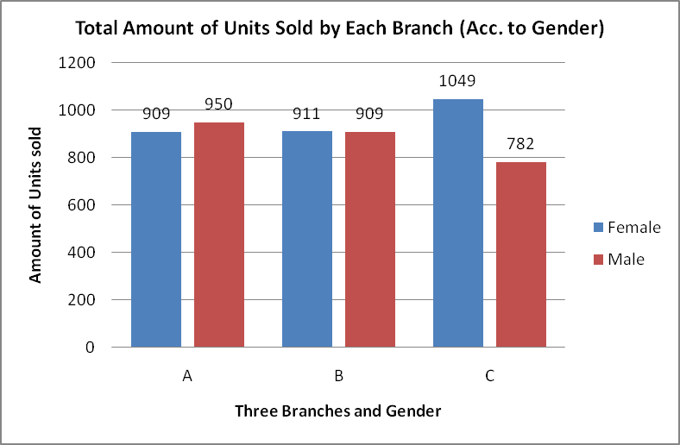

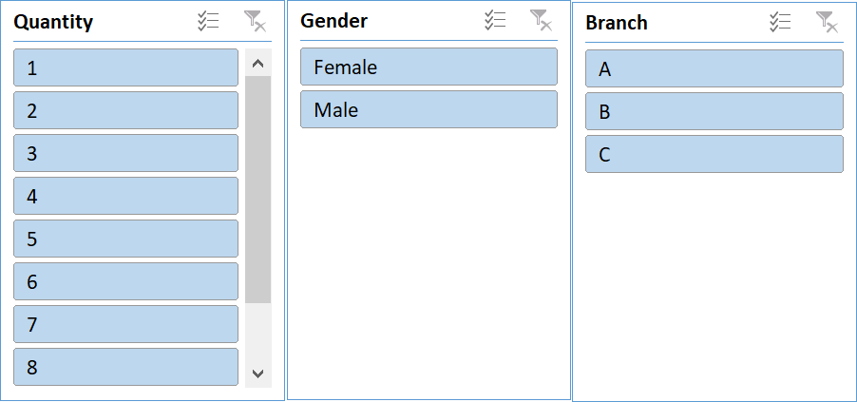

Answer. Our analysis of the Supermarket Sales Data revealed the following:

1. At Branch A, females placed the highest number of orders.
2. Branch B saw higer number of orders placed by Females
3. Meanwhile, at Branch C, males placed the most orders.

**Q3.** Compare highest and lowest rating products on the basis of units sold.

Comparison of Lowest and Highest Rating Product on basis of Units Sold

30

26

25

20

18

16

15

4

10

10

10

10

7

5

4

2

0

Electronic accessories Fashion accessories Food and beverages Health and beauty Sports and travel

Lowest and Highest Rating Product

Quantity of Units Sold

Answer. Upon analyzing the Supermarket Sales Data, we discovered that product ratings ranged from a minimum of 4 to a maximum of 10.

1. Electronic Accessories with higher ratings garnered more customer purchases, indicating a preference for quality in this category.
2. Fashion accessories and food and beverages mainly comprised lower-rated products in customer purchases.
3. Health and beauty products also leaned towards lower-rated items in customer preferences.
4. However, in the Sports and Travel category, customers showed a tendency to purchase higher-rated products.

**Q4.** Analyzing units sold and unit price data answer the following sub questions

1. What is the degree of freedom?
2. Co-relation of Unit price and revenue generated
3. What result you can draw from regression of the two data

|  |  |  |  |  |  |  |
| --- | --- | --- | --- | --- | --- | --- |
| SUMMARY OUTPUT |  |  |  |  |  |  |
|  |  |  |  |  |  |  |
| *Regression Statistics* | |  |  |  |  |  |
| Multiple R | 0.010777564 |  |  |  |  |  |
| R Square | 0.000116156 |  |  |  |  |  |
| Adjusted R Square | -0.000885732 |  |  |  |  |  |
| Standard Error | 2.924724997 |  |  |  |  |  |
| Observations | 1000 |  |  |  |  |  |
|  |  |  |  |  |  |  |
| ANOVA |  |  |  |  |  |  |
|  | *df* | *SS* | *MS* | *F* | *Significance F* |  |
| Regression | 1 | 0.9917274 | 0.991727 | 0.115937 | 0.733555221 |  |
| Residual | 998 | 8536.908273 | 8.554016 |  |  |  |
| Total | 999 | 8537.9 |  |  |  |  |
|  |  |  |  |  |  |  |
|  | *Coefficients* | *Standard Error* | *t Stat* | *P-value* | *Lower 95%* | *Upper 95%* |
| Intercept | 5.443794599 | 0.215314544 | 25.28299 | 2.1E-109 | 5.021273429 | 5.86631577 |
| Unit price | 0.001189202 | 0.003492565 | 0.340495 | 0.733555 | -0.005664411 | 0.008042815 |

Answer:

1. The degree of freedom of the analyzed data is 1.
2. The correlation between unit price and generated revenue was found to be 0.63392, indicating a moderate positive relationship. The analysis focused on the columns of unit price and total revenue, employing the CORREL function.
3. Upon examining the regression results, we aimed to discern the relationship between quantity and unit price, exploring how customers' purchasing quantity correlates with the unit price of a product.

However, from the regression analysis, it's evident that the observed trend lacks consistency. The expected outcomes derived from the trend deviate significantly from the actual outcomes.

With a degree of freedom of 1, the trendline equation stands as

Quantity = 0.0012x + 5.4438. Despite this equation, the coefficient of determination (R2) is merely 0.0001, highlighting the inconsistency in customer buying patterns solely based on unit price.

**Q5.** What product will you suggest as per the city data analysis to each type of customer

Rating vs Product Line (Preference from Customer Type)

700

635.1

653.8

597.4

657.7

600

580

542.1

547.8

516.7

570.1

523.9

593.1

555

500

400

300

Member

200

Normal

100

0

Electronic Fashion Food and Health and Home and Sports and

accessories accessories beverages beauty lifestyle travel

Product Line

Total Ratings

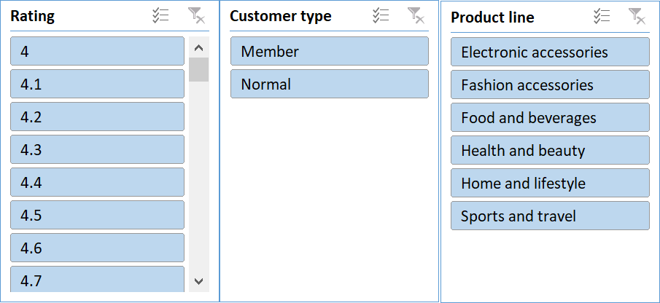

Answer. As per the city Data Analysis, **Food and Beverages** will be a good option for **Member**

type customer and **Fashion Accessories** for **Normal** type of customers.

## Conclusion and Reviews

The comprehensive analysis of supermarket sales dynamics provides valuable insights into consumer behavior, operational trends, and performance metrics. Here's a summary of the findings and reviews:

1. City Performance:

Mandalay emerged as the top-performing city among those with a 5% tax slab. Its superior sales/revenue generation signifies a potentially lucrative market for supermarket businesses.

1. Gender-based Ordering:

Female customers showed a higher propensity to order items from Branch A, while males dominated in Branch C. Branch B saw equal orders from both genders. This gender-specific trend highlights the importance of targeted marketing strategies.

1. Rating and Units Sold:

Further analysis is needed to compare products with the highest and lowest ratings based on units sold. Understanding the correlation between product ratings and sales volume can inform inventory management and marketing decisions.

1. Unit Price and Revenue Relationship:

The regression analysis revealed a weak correlation (R2 = 0.0001) between unit price and quantity sold. This suggests that customers' purchasing decisions may not be significantly influenced by unit price alone, indicating the need for deeper insights into consumer preferences and behavior.

1. Product Recommendations:

Based on city data analysis, Food and Beverages are recommended for member-type customers, while Fashion Accessories are suggested for normal customers. These recommendations align with the observed preferences and purchasing patterns in respective cities.

Reviews:

The report provides a thorough exploration of supermarket sales dynamics, covering various aspects such as city performance, gender-based ordering trends, and product recommendations.

The inclusion of regression analysis enhances the depth of insights, though further interpretation of the results could strengthen the analytical rigor.

Clear visuals, such as graphs and charts, would enhance the presentation of findings and aid in understanding complex relationships.

Overall, the report offers valuable insights for supermarket stakeholders, highlighting areas for strategic focus and improvement in marketing and operational strategies.

Introduction:

# Store Data Report

This dataset encompasses sales data from a retail store, featuring a range of attributes including customer demographics (Gender, Age Group), transaction details (OrderID, Status), product specifics (Category, SKU), and shipping information. With a focus on understanding customer behaviour and product trends, our analysis aims to uncover patterns, preferences, and correlations within the data. By leveraging these insights, businesses can optimize marketing efforts, enhance inventory management, and improve customer satisfaction.

## Questionnaire:

* 1. which of the channel performed better than all other channels in compare men & women?
  2. Compare category. Find out most sold category above 23 years of age for any gender.
  3. Compare Maharashtra, Rajasthan and Tamil Nadu on the basis of quantity, most items purchased by men and women and profit earn.
  4. Which city sold most of following categories:
     1. Kurta
     2. Set
     3. Western wears
  5. In which month most items sold in any of the state on the basis of category.

## Analytics:

1. which of the channel performed better than all other channels in compare men & women?

Ans: Amazon leads in the sales in both men and women category followed by Myntra and Flipkart. Amazon sold almost 3500 units in men category and almost 7500 units in women category. Myntra sold 2000 units in men section.

8000

7000

6000

5000

4000

3000

2000

1000

Ajio

Amazon Flipkart Meesho Myntra Nalli

Others

0

Men

Women

**Units sold**



1. Compare category. Find out most sold category above 23 years of age for any gender.

Ans: In the above 23 years of age group Kurta is most sold category in women section with 8820 units sold. Set is most sold category in men section with 4365 units sold also set is the second most sold category in women section.

The table of items sold is given below:

|  |  |  |  |
| --- | --- | --- | --- |
| **Item** | **Men** | **Women** | **Grand Total** |
| Blouse | 6 | 190 | 196 |
| Bottom | 40 | 28 | 68 |
| Ethnic Dress | 150 | 77 | 227 |
| kurta | 156 | 8820 | 8976 |
| Saree | 261 | 941 | 1202 |
| Set | 4365 | 6204 | 10569 |
| Top | 45 | 1825 | 1870 |
| Western Dress | 3078 | 380 | 3458 |
| **Grand Total** | **8101** | **18465** | **26566** |

The graph is as follows:

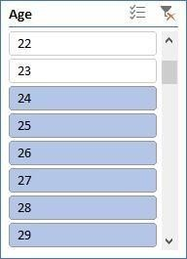



3000

2500

2000

1500

Men

1000

Women

500

0

1. Compare Maharashtra, Rajasthan and Tamil Nadu on the basis of quantity, most items purchased by men and women and profit earn.

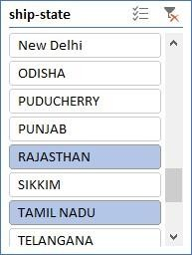Ans: In Maharashtra: Sales in men category=1390, Sales in women category= 3144 In Tamil Nadu: Sales in men category=686, Sales in women category= 2023 In Rajasthan: Sales in men category=21, Sales in women category=543

|  |  |  |  |
| --- | --- | --- | --- |
| **State** | **Men** | **Women** | **Grand Total** |
| MAHARASHTRA | 1390 | 3144 | 4534 |
| RAJASTHAN | 212 | 543 | 755 |
| TAMIL NADU | 686 | 2023 | 2709 |
| **Grand Total** | **2288** | **5710** | **7998** |

3500

3000

2500

2000

1500

Men

Women

1000

500

0

MAHARASHTRA

RAJASTHAN

TAMIL NADU

1. Which city sold most of following categories
   1. Kurta
   2. Set
   3. Western wears

Ans: Bengaluru, Chennai, Hyderabad, Mumbai and New Delhi are the cities sold most of kurtas, Sets and western wears.

450

400

350

300

250

200

150

100

kurta

Set

Western Dress

|  |  |  |  |  |  |  |
| --- | --- | --- | --- | --- | --- | --- |
| 50  0 | BENGALURU | CHENNAI |  | HYDERABAD | MUMBAI | NEW DELHI |
| kurta | 22 | 9 |  | 11 | 4 | 7 |
| Set | 409 | 190 |  | 273 | 227 | 323 |
| Western Dress | 365 | 194 |  | 327 | 190 | 121 |

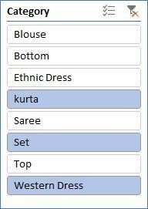

|  |  |  |  |  |
| --- | --- | --- | --- | --- |
| **City** | **kurta** | **Set** | **Western Dress** | **Grand Total** |
| BENGALURU | 964 | 938 | 422 | 2324 |
| CHENNAI | 666 | 451 | 217 | 1334 |
| HYDERABAD | 713 | 687 | 370 | 1770 |
| MUMBAI | 437 | 515 | 207 | 1159 |
| NEW DELHI | 479 | 792 | 142 | 1413 |
| **Grand Total** | **3259** | **3383** | **1358** | **8000** |

1. In which month most items sold in any of the state on the basis of category. Ans: The graph for most items sold in any of stats on basis of category is as follows:

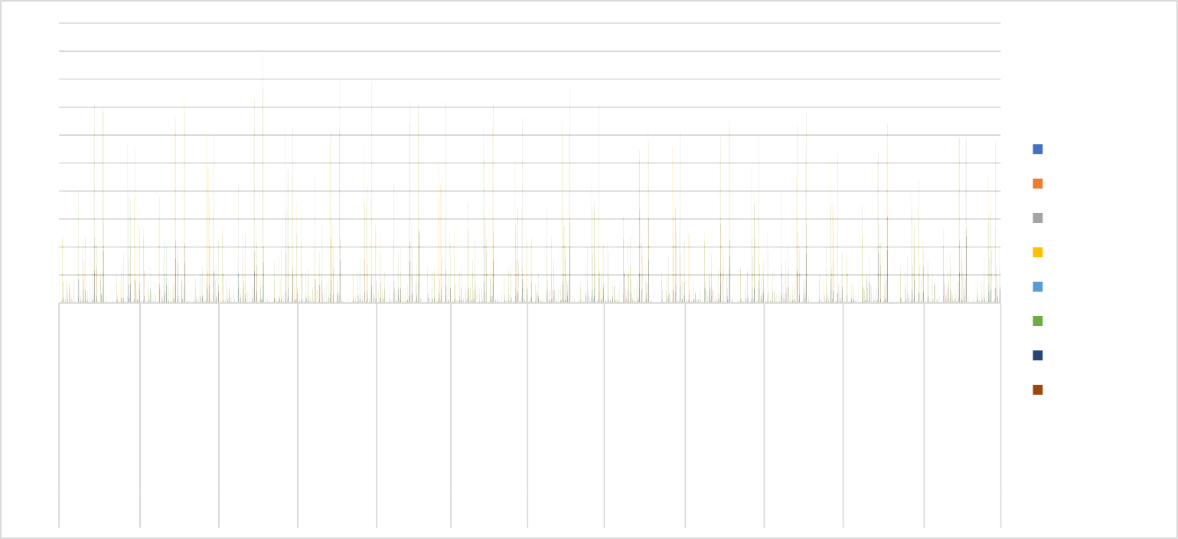

200

180

160

140

120

100

80

60

40

20

0

Blouse

Bottom Ethnic Dress kurta

Saree Set Top

Western Dress

January February March April

May

June

July August September October NovemberDecember

## Conclusion and Review:

ANDAMAN & NICOBAR

HARYANA MIZORAM UTTAR PRADESH

DELHI MAHARASHTRA TELANGANA CHHATTISGARH

LADAKH SIKKIM BIHAR KERALA PUNJAB ASSAM JHARKHAND

PUNJAB ARUNACHAL PRADESH

JHARKHAND PUDUCHERRY ANDHRA PRADESH HIMACHAL PRADESH

ODISHA ANDAMAN & NICOBAR

HARYANA MIZORAM UTTAR PRADESH

DELHI MAHARASHTRA TELANGANA CHHATTISGARH MADHYA PRADESH

SIKKIM BIHAR KARNATAKA PUDUCHERRY ANDHRA PRADESH

HIMACHAL PRADESH

After thorough analysis of the store data, it is evident that there are notable trends and insights to be gleaned. By examining key metrics such as units sold, state wise analytics, geographic, and sales across different stats and products, we can draw valuable conclusions about market demand, sales and overall profitability. This comprehensive understanding will enable informed decision-making to optimize resources, target specific markets, and maximize profits in future store sales endeavours.

# Exploring Car Data Report

## Introduction:

#### Dataset Overview:

This dataset comprises a blend of categorical and numerical data, each offering unique perspectives on the industry. Categorical data, such as make, model, and color, encapsulates the diversity of vehicles and consumer preferences. Meanwhile, numerical attributes like mileage, price, and cost provide quantifiable metrics essential for analyzing market trends and pricing dynamics.

#### Key Attributes:

1. Make: This attribute denotes the brand or manufacturer of the vehicle, offering insights into brand preferences and market share.
2. Model: The specific model of the car, providing granularity in understanding consumer choices and preferences within each brand.
3. Color: Reflects the color of the vehicle, which can influence consumer perception and aesthetic preferences.
4. Mileage: Indicates the distance traveled by the vehicle, a crucial factor influencing its value and pricing.
5. Price: Represents the listed price of the vehicle, serving as a key determinant in consumer purchasing decisions and market competitiveness.
6. Cost: Denotes the cost associated with acquiring the vehicle, which includes factors such as production costs, dealer margins, and other expenses.

## Questionnaire:

Q1. Compare the mileage of Chevrolet Impala to Toyota Corolla. Which of the two is giving best mileage?

Q2. Justify, Buying of any Ford car is better than Honda

Q3. Among all the cars which car color is the most popular and is least popular?

Q4. Compare all the cars which are of silver color to the green color in terms of Mileage. Q5. Find out all the cars, and their total cost which is more than $2000?



## Analytics:

Q1. Compare the mileage of Chevrolet Impala to Toyota Corolla. Which of the two is giving best mileage?

Ans. Toyota Corolla gives better mileage than Chevrolet Impala.

300,000

250,000

200,000

Comparesion the mileage of Chevrolet Impala to

Toyota Corolla

277,131

228,486

150,000

100,000

50,000

0

Toyota

Chevrolet

Corolla

Impala

Total

|  |
| --- |
| 59,169  87,278  87,675  130,684  140,811 |
|  |
| 40,826 |
| 41,560 |
| 42,542 |



Q2. Justify, Buying of any Ford car is better than Honda.

Ans. Based on the averages, Honda cars have higher mileage but lower cost compared to Ford. Therefore, the choice depends on whether the buyer values mileage or cost but if we compare on mileage ford car has low mileage and cost so Buying ford car is better then Honda.

Ford vs Honda Car Comparision

300000

260001

250000

200000

150000

~~138789~~

104085

100000

89073

49326

50000

42542

41560

7593 6950

3950 3000

2659 2100

3706 3100

8500 6500

2723 1900

4745 4100

0

Escape

F−150

Fusion

Mustang

Accord

Civic

Honda

CRV

Ford

Sum of Price Sum of Cost Sum of Mileage

|  |
| --- |
| 40826 |
| 41560 |
| 42542 |
| 49326 |
| 63259 |
| 63512 |
| 89073 |
| 95135 |

|  |
| --- |
| 2000 |
| 2500 |
| 2659 |
| 2723 |
| 3196 |
| 3706 |
| 3950 |
| 4000 |



1500

1900

2000

2100

3000

3050

3100

3900

Q3. Among all the cars which car color is the most popular and is least popular?

Ans. Most popular color is Silver and Black as each appear 6 times

and least appearing colour are Blue ,Green ,Red ,White they all apper 3 times.

Color count

7

6

6

6

5

4

3 Total 2

1

0

Black Blue Green Red Silver White

|  |  |  |  |  |  |  |  |  |  |  |  |  |
| --- | --- | --- | --- | --- | --- | --- | --- | --- | --- | --- | --- | --- |
|  |  |  | | | | | | |  |  | | |
|  |  | | | | | | |  | | |
|  | 3 3 3 | | | | | | | 3 | | |
|  |  |  |  |  |  |  |  |  |  |  |
|  |  |  |  |  |  |  |
|  |  |  |  |  |  |  |



Escape

CRV

Corolla

Civic

Charger

Camry

Altima

Accord



White

Silver

Red

Green

Blue

Black



69847

101354

87675

Q4. Compare all the cars which are of silver color to the green color in terms of Mileage.

Ans. Silver color car millage is more than green color car milage if we compare there average.

Silver vs Green Car Mileage Comparision

450000

400000

350000

300000

250000

200000

150000

100000

50000

0

382784

234311

Total

Green Silver

|  |
| --- |
| 34853 |
| 41560 |
| 55233 |
| 58173 |
| 59169 |



Black

Silver

(blank)

White

Red

Green

Blue



Q5. Find out all the cars, and their total cost which is more than $2000? Ans. All the car mention below cost is more than $2000

Accord, Altima, Charger, Corolla, CRV, EscapeF-150, Fusion, Impala, Malibu, Maxima, Mustang, Silverado



Cars with cost more then $2000

10000

9000

8000

7000

6000

5000

4000

3000

2000

1000

0

9300

6500

6300

6950

5500

5500

4100

4500

3000

3000

3100

2100

2500

Total

|  |
| --- |
| Accord |
| Altima |
| Camry |
| Charger |
| Civic |
| Corolla |
| CRV |
| Escape |

|  |
| --- |
| $1,500 |
| $1,800 |
| $1,900 |
| $2,000 |
| $2,100 |
| $2,200 |
| $2,500 |
| $3,000 |

#### Regression

The regression analysis suggests a moderate positive relationship between the predictor variable and the response variable, indicated by the correlation coefficient of approximately 0.40. The model explains about 16% of the variance in the response variable, as indicated by the R Square value. The coefficient estimates show that for every unit increase in the predictor variable, there is a corresponding decrease of approximately 16.66 in the response variable, with a p-value of 0.056, indicating a marginally significant effect.

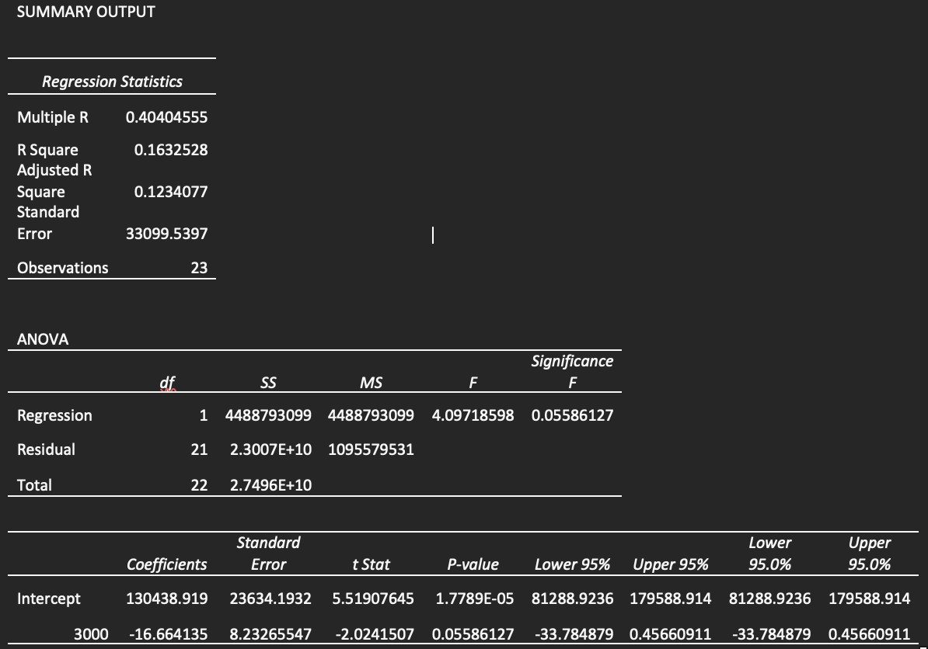

#### Co-relational

The correlation matrix indicates a moderate negative correlation (-0.411) between Mileage and Price. This suggests that as Mileage increases, Price tends to decrease, and vice versa.

|  |  |  |
| --- | --- | --- |
|  | *Mileage* | *Price* |
| Mileage | 1 |  |
| Price | -0.4110586 | 1 |

#### Anova: Single Factor

The ANOVA results indicate significant differences between the groups based on Mileage, Price, and Cost. The F-statistic is large (128.88), with a very low p-value (5.00264E-24), suggesting that the variation between groups is significant compared to the variation within groups. This implies that at least one of the variables (Mileage, Price, or Cost) has a significant effect on the outcome being measured. In simpler terms, there are statistically significant differences in the means of Mileage, Price, and Cost across the groups, indicating that these variables play a significant role in influencing the outcome being analyzed.

|  |  |  |  |  |  |  |
| --- | --- | --- | --- | --- | --- | --- |
| Anova: Single  Factor |  |  |  |  |  |  |
| SUMMARY | | | | |  |  |
| *Groups* | *Count* | *Sum* | *Average* | *Variance* |  |  |
| Mileage | 24 | 2011267 | 83802.7917 | 1214155660 |  |  |
| Price | 24 | 78108 | 3254.5 | 837024.087 |  |  |
| Cost | 24 | 66150 | 2756.25 | 705502.717 |  |  |
| ANOVA | | | | | | |
| *Source of Variation* | *SS* | *df* | *MS* | *F* | *P-value* | *F crit* |
| Between Groups | 1.0445E+11 | 2 | 5.2227E+10 | 128.882161 | 5.0026E-24 | 3.12964398 |
| Within Groups | 2.7961E+10 | 69 | 405232729 |  |  |  |
| Total | 1.3242E+11 | 71 |  |  |  |  |

#### Anova: Two-Factor Without replication

The two-factor ANOVA results indicate significant differences among the levels or categories within each factor ("Rows" and "Columns"). Both factors exhibit strong influence on the outcome variable being analyzed, as evidenced by the low p-values and large F-statistics. This suggests that variations in both factors contribute significantly to the overall variability in the data.

|  |  |  |  |  |  |  |
| --- | --- | --- | --- | --- | --- | --- |
| Anova: Two-Factor without replication | | | | | | |
| ANOVA |  |  |  |  |  |  |
| *Source of Variation* | *SS* | *df* | *MS* | *F* | *P-value* | *F crit* |
| Rows | 34749383.3 | 23 | 1510842.75 | 47.6846408 | 2.2236E-14 | 2.01442484 |
| Columns | 2979036.75 | 1 | 2979036.75 | 94.023218 | 1.3629E-09 | 4.27934431 |
| Error | 728733.25 | 23 | 31684.0543 |  |  |  |
| Total | 38457153.3 | 47 |  |  |  |  |

#### Descriptive Statistics

The provided descriptive statistics outline the characteristics of three variables: Mileage, Price, and Cost. Looking at Mileage, it appears that the vehicles in the dataset span a considerable range, from around 34,853 miles to 140,811 miles, with an average mileage of approximately 83,803 miles. Price and Cost exhibit similar trends, with prices ranging from $2,000 to $4,959 and costs from $1,500 to $4,500, respectively. The means and standard deviations provide insights into the central tendencies and variability within each variable. Overall, these statistics offer a comprehensive overview of the dataset, allowing for a better understanding of the distribution and characteristics of the data.

|  |  |  |  |  |  |
| --- | --- | --- | --- | --- | --- |
| *Mileage* |  | *Price* |  | *Cost* |  |
| Mean | 83802.7917 | Mean | 3254.5 | Mean | 2756.25 |
| Standard Error | 7112.65205 | Standard Error | 186.751181 | Standard Error | 171.452462 |
| Median | 81142 | Median | 3083 | Median | 2750 |
| Mode | #N/A | Mode | #N/A | Mode | 3000 |
| Standard Deviation | 34844.7365 | Standard Deviation | 914.890205 | Standard Deviation | 839.942092 |
| Sample Variance | 1214155660 | Sample Variance | 837024.087 | Sample Variance | 705502.717 |
| Kurtosis | -1.0971827 | Kurtosis | -1.2029138 | Kurtosis | -0.8126576 |
| Skewness | 0.38652215 | Skewness | 0.27201913 | Skewness | 0.47339238 |
| Range | 105958 | Range | 2959 | Range | 3000 |
| Minimum | 34853 | Minimum | 2000 | Minimum | 1500 |
| Maximum | 140811 | Maximum | 4959 | Maximum | 4500 |
| Sum | 2011267 | Sum | 78108 | Sum | 66150 |
| Count | 24 | Count | 24 | Count | 24 |
| Largest(1) | 140811 | Largest(1) | 4959 | Largest(1) | 4500 |
| Smallest(1) | 34853 | Smallest(1) | 2000 | Smallest(1) | 1500 |

#### Conclusion & Review

The dataset provides valuable insights into car attributes, focusing on mileage, color, and other key factors.

Here's a simple conclusion based on the data:

Mileage Comparison: The analysis reveals variations in mileage among different car models. Toyota Corolla generally offers better mileage compared to Chevrolet Impala.

Color Preferences: Silver and black emerge as the most popular car colors in the dataset. Blue, green, red, and white are among the least popular color choices.

Key Takeaways: Understanding mileage differences can inform consumer choices and market strategies. Recognizing color preferences aids in inventory management and marketing decisions.

**EXPLORING SALES OF DIFFERENT SEGMENT IN US STATES**

## INTRODUCTION:

Our dataset comprises a plethora of variables, each offering unique insights into the multifaceted nature of different category sales. From fundamental transactional details such as Date, Time, sales, states to more nuanced factors like Customer Type, Demographics, category and sub category, every facet has been meticulously documented.

Key Attributes:

1. ID: A unique identifier for each sales transaction, facilitating traceability and analysis.
2. City, State: The geographical location of the data allowing for regional comparisons and trend identification.
3. Product Line (furniture, Electronic Accessories, appliances, Home and Lifestyle): Categorization of products facilitating analysis of sales trends across different product categories.
4. Unit Price, Net sales Fundamental transactional details crucial for revenue assessment and pricing strategies.
5. Net sales of different category, category performing well in different states: Performance metrics
6. Rating: different product performing well in different state
7. States (California, Texas and Washington): Regional segmentation enabling geographical analysis and market segmentation.

2. QUESTIONNAIRE:

1. Compare all the US states in terms of Segment and Sales. Which Segment performed well in all the states?
2. Find out top performing category in all the states?
3. Which segment has most sales in US, California, Texas, and Washington?
4. Compare total and average sales for all different segment?
5. Compare average sales of different category and sub category of all the states.

## ANALYTICS:

**Q1.** Compare all the US states in terms of Segment and Sales. Which Segment performed well in all the states?

Sales of Different Segments in Different States

250000

200000

150000

100000

50000

Consumer

Corporate Home Office

0

States

Sales

* + After comparing all the states in terms of segment and sales, California emerged as the state with the highest amount of sales

Alabama

Arkansas Colorado Delaware Florida Idaho Indiana Kansas Louisiana Maryland Michigan Mississippi Montana Nevada New Jersey New York

North Dakota Oklahoma Pennsylvania South Carolina Tennessee

Utah Virginia

West Virginia Wyoming

* + Consumer segment performed well in all the states

### Slicers:

**Q2.** Find out top performing category in all the states?

**Top categories in all sales**

7000

6000

5000

4000

3000

2000

Total

1000

0

Furniture

Office Supplies

**Category**

Technology

**count of sales**

Ans. Office Supplies is the top performing category in all the states

### Slicers:

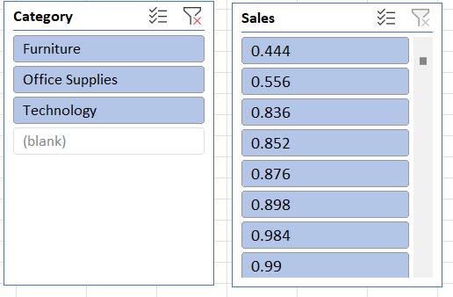

**Q3.** Which segment has most sales in US, California, Texas, and Washington?

1200

1000

800

600

400

Consumer

Corporate Home Office

200

0

California

Texas

**state**

Washington

**sales**

Ans. Consumer segment has the most sales in US, California, Texas, and Washington

### Slicers:

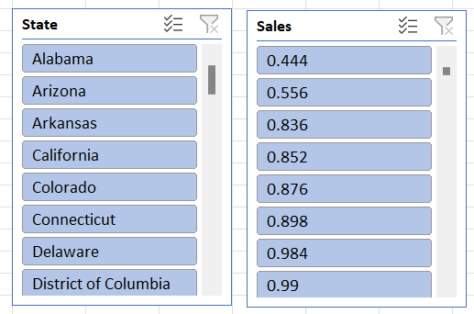

**Q4.** Compare total and average sales for all different segment?

Total vs Average Sales of Different Segments

1400000

1200000 ~~1148060.531~~

1000000

800000

688494.0748

600000

400000

424982.1769

Sum of Sales

Average of Sales

200000

225.0657775

233.1507195

243.4033086

0

Consumer

Corporate

Home Office

**Segments**

sum of sales and average sales

**Ans.** By Analysis of the given data set we can found that in all the three segments the total sales were greater than the average sales.

**Q5.** Compare average sales of different category and sub category of all the states.

350000

322822.731

327782.448

300000

Accessories

Appliances Art

250000

Binders

219343.392

202810.622800028.785

Bookcases

200000

189238.631

Chairs

146248.094

150000

113813.1987

104618.403

100000

89212.018

76828.304

46420.308

Copiers

Envelopes Fasteners Furnishings Labels

50000

26705.41

Machines

161281.2034467.726

3001.96

Paper

0

Furniture

Office Supplies

Axis Title

Technology

Phones

Storage

Axis Title

Ans. By doing analysis of the given Order Sales dataset we were able to observe that, average sales of Technology was far greater than rest of the categories

### Regression and ANOVA:

|  |  |  |  |  |
| --- | --- | --- | --- | --- |
| SUMMARY OUTPUT | |  |  |  |
|  |  |  |  |  |
| *Regression Statistics* | |  |  |  |
| Multiple R | 0.008850713 |  |  |  |
| R Square | 7.83351E-05 |  |  |  |
| Adjusted R Square | -0.000924595 |  |  |  |
| Standard Error | 596.4161586 |  |  |  |
| Observations | 999 |  |  |  |
|  |  |  |  |  |
| ANOVA |  |  |  |  |
|  | *Df* | *SS* | *MS* | *F* |
| Regression | 1 | 27783.3433 | 27783.3433 | 0.078106235 |
| Residual | 997 | 354645097.6 | 355712.2343 |  |
| Total | 998 | 354672880.9 |  |  |
|  |  |  |  |  |
|  | *Coefficients* | *Standard Error* | *t Stat* | *P-value* |
| Intercept | 232.3779806 | 37.2042048 | 6.246013907 | 6.22491E-10 |
| Postal Code | 0.000167458 | 0.000599189 | 0.279474927 | 0.779938343 |

This regression analysis aims to examine the relationship between two variables: an independent variable represented by "Postal Code" and a dependent variable (not explicitly mentioned in the output). Here's an explanation of the key components:

1. Regression Equation:

The regression equation is of the form:

Y = 232.38 + 0.000167458* (Postal Code)

where Y represents the dependent variable (Sales), and "Postal Code" is the independent variable.

1. Interpretation of Coefficients:

The intercept coefficient (232.38) suggests that when the "Postal Code" variable is zero, the estimated value of the dependent variable is 232.38. However, the interpretation of this intercept may not be meaningful since postal codes are unlikely to be zero.

The coefficient for "Postal Code" (0.000167458) suggests that for every one-unit increase in the postal code, the estimated value of the dependent variable increases by approximately

0.000167458 units. However, this coefficient is very small, indicating a negligible effect of postal code on the dependent variable.

1. Statistical Significance:

The p-value associated with the coefficient for "Postal Code" is 0.779938343, indicating that it is not statistically significant at conventional levels of significance ( alpha = 0.05). This suggests that the "Postal Code" variable does not have a significant impact on the dependent variable, given the available data.

1. Goodness of Fit:

* The R-squared value (0.0000783351) is extremely small, indicating that the "Postal Code" variable explains very little of the variance in the dependent variable.
* The Adjusted R-squared value (-0.000924595) is negative, which can happen when the model is over fit or when the independent variable is not relevant. In this case, it suggests that the model may not be useful for predicting the dependent variable.

1. ANOVA:

* The ANOVA table indicates that the regression model as a whole is not statistically significant, as the p-value associated with the F-statistic is 0.779938343.

1. Standard Error:

* The standard error (596.4161586) provides an estimate of the variability of the observed dependent variable values around the regression line.

1. Observations:

* The analysis is based on a sample of 999 observations.

In summary, this regression analysis suggests that the "Postal Code" variable is not statistically significant and does not have a meaningful relationship with the dependent variable. Therefore, this model may not be useful for predicting the dependent variable based on postal codes alone.

### Correlation:

The absolute value of the correlation coefficient (0.024067424) is close to zero. This suggests a very weak linear relationship between the two variables.

### Descriptive Statistics:

*Sales*

|  |  |
| --- | --- |
| Mean | 230.7691 |
| Standard Error | 6.33014 |
| Median | 54.49 |
| Mode | 12.96 |
| Standard Deviation | 626.6519 |
| Sample Variance | 392692.6 |
| Kurtosis | 304.4451 |
| Skewness | 12.98348 |
| Range | 22638.04 |
| Minimum | 0.444 |
| Maximum | 22638.48 |
| Sum | 2261537 |

Count 9800

## 4. CONCLUSION:

Our comprehensive analysis of the provided dataset through various data visualization techniques has yielded valuable insights. Through the creation of bar graphs, pie charts, and other visual representations, we've been able to discern patterns, trends, and relationships within the data that might have otherwise remained obscured.

Our deep dive into the dataset has not only enhanced our understanding of the underlying information but has also empowered us to make informed decisions based on the insights gained. By visually depicting the data, we've been able to communicate complex findings in a clear and accessible manner, facilitating better comprehension and actionable strategies.

Furthermore, this process has underscored the importance of data visualization as a powerful tool for extracting meaningful information from raw data. By harnessing the visual nature of graphs and charts, we've transformed numbers and statistics into compelling narratives that drive understanding and inform decision-making.

# Loan Data Report

## Introduction:

#### Dataset Overview:

Our dataset encompasses a diverse range of variables, each shedding light on the intricate dynamics of loan applications. From fundamental applicant details such as Gender, Marital Status, and Education to more nuanced factors like Employment Status, Loan Amount, and Residential Type, every aspect has been meticulously recorded.

#### Key Attributes:

1. Gender: A demographic identifier providing insights into the gender distribution among loan applicants.
2. Marital Status (Married, Not Married): Categorization based on marital status aiding in demographic segmentation.
3. Education (Graduate, Non-graduate): Classification based on educational background for further analysis.
4. Employment Status (Employed, Unemployed): Distinction between employed and unemployed applicants, crucial for risk assessment.
5. Loan Amount: The principal amount applied for, providing a measure of financial need and capacity.
6. Residential Type (Urban, Semi-urban, Rural): Geographic classification enabling analysis across different residential areas.

## Questionnaire:

Q1. How many male graduates who are not married applied for Loan? What was the highest amount?

Q2. How many female graduates who are not married applied for Loan? What was the highest amount?

Q3. How many male non-graduates who are not married applied for Loan? What was the highest amount?

Q4. How many female graduates who are married applied for Loan? What was the highest amount?

Q5. How many male and female who are not married applied for Loan? Compare Urban, Semi- urban and rular on the basis of amount.

## Analytics:



##### Q1. How many male graduates who are not married applied for Loan? What was the highest amount?

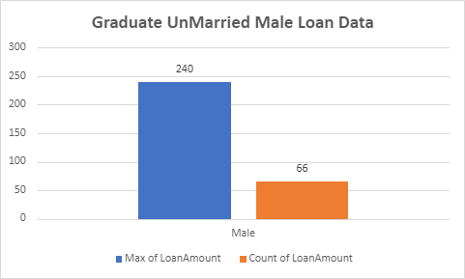

|  |
| --- |
| Female |
| Male |
| (blank) |

|  |
| --- |
| No |
| Yes  (blank) |

|  |
| --- |
| Graduate |
| Not Graduate  (blank) |

Q2. How many female graduates who are not married applied for Loan? What was the highest amount?

**Graduate UnMarried Female Loan Data**

350

300

300

250

200

150

100

50

0

Female

Max of LoanAmount

Count of LoanAmount

|  |  |  |
| --- | --- | --- |
|  |  |  |
|  |  |
|  |  |
|  |  |
|  | 35 |
|  |



Male

(blank)

Yes

(blank)

Not Graduate

(blank)

Graduate

No

Female

Q3. How many male non-graduates who are not married applied for Loan? What was the highest amount?



**NonGraduate UnMarried Male Loan Data**

250

199

200

150

100

50

0

Male

Max of LoanAmount Count of Gender



|  |  |  |
| --- | --- | --- |
|  |  |  |
|  |  |
|  |  |
|  | 16 |

|  |
| --- |
| Male |
| (blank) |

|  |
| --- |
| No |
| (blank) |

|  |
| --- |
| Not Graduate |
| (blank) |

Q4. How many female graduates who are married applied for Loan? What was the highest amount?

500

**Graduate Married Female Loan Data**

460

450

400

350

300

250

200

150

100

50 21

0

Female

Max of LoanAmount

Count of Gender



Female



Yes



Graduate

Q5. How many male and female who are not married applied for Loan? Compare Urban, Semi-urban and rular on the basis of amount.

**UnMarried Male and Female who applied for Loan**

44

82

Female Male



Male

Female



No

Comparision of Loan Amount on basis of

Property Area

5200

5165

5167

5150

5100

5050

5000 4976

4950

4900

4850

Rural Semiurban Urban



(blank)

Urban

Semiurban

Rural



64

60

59

55

50

46

40

28

## Conclusion:

Our analysis, using varied visualization techniques, revealed valuable insights, enhancing comprehension and decision-making. Visualizing data clarified complex findings, facilitating actionable strategies. This highlights the pivotal role of data visualization in extracting meaningful insights and informing decisions effectively.

## Regression:

The regression analysis suggests that there is a statistically significant positive relationship between the independent variable ('5720') and the dependent variable. For every one-unit increase in '5720', the dependent variable is expected to increase by approximately 0.0059 units. However, it's important to note that the model only accounts for about 21.1% of the total variance in the dependent variable.

|  |  |  |  |  |  |  |  |
| --- | --- | --- | --- | --- | --- | --- | --- |
| SUMMARY OUTPUT | | | | | | | |
| *Regression Statistics* | | | | | | | |
| Multiple R | 0.45908096 |  |  |  |  |  |  |
| R Square | 0.21075532 |  |  |  |  |  |  |
| Adjusted R Square | 0.20858707 |  |  |  |  |  |  |
| Standard Error | 56.0766111 |  |  |  |  |  |  |
| Observations | 366 |  |  |  |  |  |  |
| ANOVA |  |  |  |  |  |  |  |
|  | *df* | *SS* | *MS* | *F* | *Significance F* |  |  |
| Regression | 1 | 305655.205 | 305655.205 | 97.2004502 | 1.7676E-20 |  |  |
| Residual | 364 | 1144629.42 | 3144.58631 |  |  |  |  |
| Total | 365 | 1450284.62 |  |  |  |  |  |
|  |  |  |  |  |  |  |  |
|  | *Coefficients* | *Standard Error* | *t Stat* | *P-value* | *Lower 95%* | *Upper 95%* | *Lower 95.0%* |
| Intercept | 106.07753 | 4.10024098 | 25.8710478 | 1.7585E-84 | 98.014396 | 114.140665 | 98.01439 |
| 5720 | 0.0058851 | 0.00059692 | 9.85902887 | 1.7676E-20 | 0.00471125 | 0.00705895 | 0.004711 |

## Co-Relation:

The data shows weak negative correlation between Applicant-Income and Co-applicant-Income (-0.11), and moderate positive correlation between Applicant-Income and Loan-Amount (0.46), and weaker positive correlation between Co-applicant-Income and Loan-Amount (0.14).

|  |  |  |  |
| --- | --- | --- | --- |
| *ApplicantIncome* | | *CoapplicantIncome* | *LoanAmount* |
| ApplicantIncome | 1 |  |  |
| CoapplicantIncome | -0.110334799 | 1 |  |
| LoanAmount | 0.458768926 | 0.144787815 | 1 |

## Anova (Single Factor) :

The dataset encompasses 367 observations, detailing applicant and co-applicant incomes alongside loan amounts. On average, applicants possess a higher income, averaging around

$4805.60, compared to co-applicants whose average income is approximately $1569.58. Loan amounts vary widely, averaging $134.28. ANOVA analysis underscores significant distinctions between the income and loan amounts across the groups, implying diverse financial profiles among applicants and co-applicants.

|  |  |  |  |  |  |  |
| --- | --- | --- | --- | --- | --- | --- |
| SUMMARY | | | | |  |  |
| *Groups* | *Count* | *Sum* | *Average* | *Variance* |  |  |
| ApplicantIncome | 367 | 176365  5 | 4805.59945  5 | 24114831.0  9 |  |  |
| CoapplicantIncom  e | 367 | 576035 | 1569.57765  7 | 5448639.49  1 |  |  |
| LoanAmount | 367 | 49280 | 134.277929  2 | 3964.14112  4 |  |  |
| ANOVA |  |  |  |  |  |  |
| *Source of*  *Variation* | *SS* | *df* | *MS* | *F* | *P-value* | *F crit* |
| Between Groups | 4202537452 | 2 | 2101268726 | 213.200984  1 | 5.87569E-  79 | 3.00392057  7 |
| Within Groups | 1082168110  7 | 1098 | 9855811.57  3 |  |  |  |
| Total | 1502421856 | 1100 |  |  |  |  |

#### Anova two factor without Replication:

The ANOVA results indicate significant variation both within rows (p = 0.441) and between columns (p < 0.001). This suggests that there are meaningful differences among the row categories and column categories in the dataset, warranting further investigation into the factors influencing these variations.

|  |  |  |  |  |  |  |
| --- | --- | --- | --- | --- | --- | --- |
| ANOVA |  |  |  |  |  |  |
| *Source of Variation* | *SS* | *df* | *MS* | *F* | *P-value* | *F crit* |
| Rows | 1004340909 | 365 | 2751618.93 | 1.015674698 | 0.440986529 | 1.1881716 |
| Columns | 379216841.8 | 1 | 379216841.8 | 139.9761235 | 1.47092E-27 | 3.867061668 |
| Error | 988841123.7 | 365 | 2709153.763 |  |  |  |
| Total | 2372398875 | 731 |  |  |  |  |

#### Descriptive Statistics:

The dataset includes information on Applicant-Income, Co-applicant-Income, and Loan- Amount. The largest Applicant-Income recorded is $72,529, while the smallest is $0. For Co- applicant-Income, the largest value is $24,000, and the smallest is $0. Additionally, the Loan- Amount ranges from a maximum of $550 to a minimum of $0. Confidence levels for these variables at a 95.0% level are also provided, indicating the precision of the measurements within the dataset.

|  |  |  |  |  |  |
| --- | --- | --- | --- | --- | --- |
| Largest(1) | 72529 | Largest(1) | 24000 | Largest(1) | 550 |
| Smallest(1) | 0 | Smallest(1) | 0 | Smallest(1) | 0 |
| Confidence  Level(95.0%) | 504.0756  067 | Confidence  Level(95.0%) | 239.6059  543 | Confidence  Level(95.0%) | 6.462910  219 |

**Shop Sales Data Report**

## Introduction:

This dataset encapsulates a wealth of information regarding sales transactions, providing valuable insights into the dynamics of retail operations. With columns meticulously crafted to capture key facets of each transaction, including Date, Salesman, Item Name, Company, Quantity, and Amount, analysts and businesses alike gain access to a treasure trove of actionable data.

Whether it's uncovering trends, optimizing inventory management, or refining sales strategies, this dataset serves as an invaluable resource for driving informed decision-making and unlocking new avenues for growth.

## Questionnaire:

* 1. Compare all the salesmen on the basis of profit earn.
  2. Find out most sold product over the period of May-September.
  3. Find out which of the two product sold the most over the year Computer or Laptop?
  4. Which item yield most average profit?
  5. Find out average sales of all the products and compare them.

## Analytics:

1. Compare all the salesmen on the basis of profit earn.

Ans:- The comparison of all the salesmen on the basis of profit earned is given below:

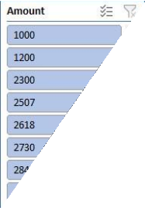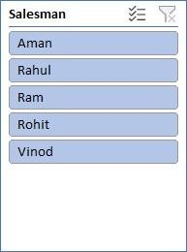

Comparing salesmen on the

basis of Profit Earned

500000

480000

460000

440000

420000

400000

380000

360000

414776.44

47

Total

Aman Rahul Ram Rohit Vinod

1. Find out most sold product over the period of May-September.

Ans:- To identify the most sold product over the period of May-September, we would need to analyze the sales data within this timeframe. By aggregating the quantity sold for each product across all transactions during this period and then determining which product has the highest total quantity sold, we can pinpoint the most popular item.

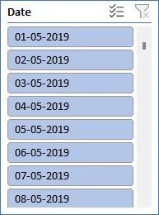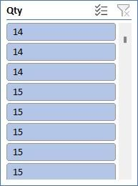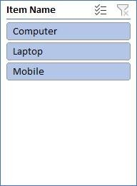

**Most Sold Product**

SEP

**764.0629212**

AUG

**712.7183647**

JUL

**634.6458094**

JUN

**539.8378925**

MAY

**481.0191684**

0

200

400

600

800 1000

Total

1. Find out which of the two product sold the most over the year Computer or Laptop? Ans:- The two product sold the most over the year between computer or laptop :

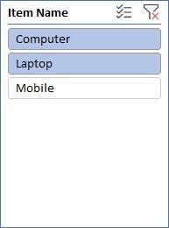 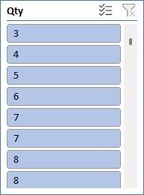



**Total**

**52%**

**48%**

Computer

Laptop

4 . Which item yield most average profit?

Ans:- The item that yields the most profit between laptop, computer and mobile is :

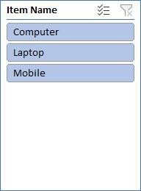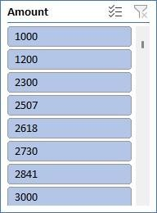

**MOST AVERAGE PROFIT**

Total

C O M P U T E R

L A P T O P

M O B I L E

6770.231898

6772.950369

7057.58477

5. Find out average sales of all the products and compare them.

Ans:- The average sales of all the products with their respective comparison is :

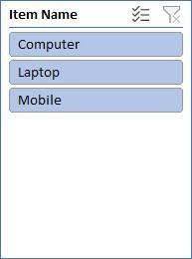

**AVERAGE SALES**

Mobile

Laptop

Total

Computer

6600

6800

7000

7200

## Conclusion and Review :

The shop sales dataset offers insights into sales trends, salesman performance, item popularity, and company performance. Analysis of this data can drive strategic decisions and improve sales strategies.

The dataset is well-structured and provides comprehensive information on sales transactions. It allows for various analyses, but could benefit from additional variables for deeper insights.Overall, it's a valuable resource for understanding sales dynamics and informing business decisions.

Regression:

The regression model, with a significant p-value indicates a strong positive relationship between Amount and the profit earned and the outcome variable. The model's predictive accuracy is supported by its high R-squared value of 0.660.

|  |  |  |  |  |  |  |
| --- | --- | --- | --- | --- | --- | --- |
| SUMMARY OUTPUT | | | | | | |
| *Regression Statistics* | | | | | | |
| Multiple R | 0.812617 |  |  |  |  |  |
| R Square | 0.660347 |  |  |  |  |  |
| Adjusted R Square | 0.629469 |  |  |  |  |  |
| Standard Error | 1215.119 |  |  |  |  |  |
| Observations | 13 |  |  |  |  |  |
| ANOVA |  | | | | | |
|  | *df* | *SS* | *MS* | *F* | *Significance F* |  |
| Regression | 1 | 31576697 | 31576697 | 21.38598 | 0.000753 |  |
| Residual | 11 | 16241653 | 14776514 |  |  |  |
| Total | 12 | 47818350 |  |  |  |  |
|  |  |  |  |  |  |  |
|  | *Coefficients* | *Standard Error* | *t Stat* | *P-value* | *Lower 95%* | *Upper 95%* |
| Intercept | 244.7062 | 754.0557 | 0.32452 | 0.751632 | -1414.96 | 1904.372 |
| X Variable | 0.190729 | 0.041243 | 4.624498 | 0.000735 | 0.099954 | 0.281505 |

#### Co-relation:

The correlation coefficient between units sold and revenue is 0.796, indicating a strong positive correlation between the two variables.

|  |  |  |
| --- | --- | --- |
|  | *Qty* | *Amount* |
| Column  1 | 1 |  |
| Column  2 | #DIV/0! | 1 |

#### Anova (Single Factor) :

The ANOVA results indicate a significant difference between the two groups , with 1 degree of freedom.

|  |  |  |  |  |  |  |
| --- | --- | --- | --- | --- | --- | --- |
| SUMMARY |  |  |  |  |  |  |
| Groups | Count | Sum | Average | Variance |  |  |
| Column 1 | 15 | 78.56643 | 5.237762 | 2.766871 |  |  |
| Column 2 | 15 | 50419.05 | 3361.27 | 3416099 |  |  |
|  |  |  |  |  |  |  |
| ANNOVA |  |  |  |  |  |  |
| Source of Variance | SS | df | MS | F | P-Value | F crit |
| Between Group | 84472135 | 1 | 84472135 | 49.45528 | 1.2E-07 | 4.195972 |
| Without Group | 47825420 | 28 | 170851 |  |  |  |
|  |  |  |  |  |  |  |
| Total | 1.32E+08 | 29 |  |  |  |  |

#### Anova two factor with Replication:

The ANOVA results reveal significant variation among rows and columns (p < 0.001), with degrees of freedom (df) values of 10 respectively. The error term has a degree of freedom of 0

|  |  |  |  |  |  |  |
| --- | --- | --- | --- | --- | --- | --- |
| ANOVA |  |  |  |  |  |  |
| *Source of*  *Variation* | *SS* | *df* | *MS* | *F* | *P-value* | *F crit* |
| Rows | 841600745 | 10 | 4160074 | 65535 | #NUM! | #NUM! |
| Columns | 0 | 0 | 65535 | 65535 | #NUM! | #NUM! |
| Error | 0 | 0 | 65535 |  |  |  |
| Total | 41600745 | 10 |  |  |  |  |

#### Anova two factor without Replication:

|  |  |  |  |  |  |  |
| --- | --- | --- | --- | --- | --- | --- |
| Summary | Count | Sum | Average | Variance |  |  |
| 4 | *1* | *7800* | *7800* | *#DIV/0!* |  |  |
| 5 | *1* | *3000* | *3000* | *#DIV/0!* |  |  |
| 4 | 1 | 2300 | 2300 | *#DIV/0!* |  |  |
| 3 | 1 | 7000 | 7000 | *#DIV/0!* |  |  |
| 3 | 1 | 1200 | 1200 | *#DIV/0!* |  |  |
| 4 | 1 | 2506.667 | 2506.667 | *#DIV/0!* |  |  |
| 5 | 1 | 2618.095 | 2618.095 | *#DIV/0!* |  |  |
| 6 | 1 | 2729.524 | 2729.524 | *#DIV/0!* |  |  |
| 7 | 1 | 2840.952 | 2840.952 | *#DIV/0!* |  |  |
| 6 | 1 | 4500 | 4500 | *#DIV/0!* |  |  |
| 7 | 1 | 3063.81 | 3063.81 | *#DIV/0!* |  |  |
|  |  |  |  |  |  |  |
| 1000 |  | 39559.05 | 3596.277 | 4160074 |  |  |

Descriptive Statistics:

|  |  |
| --- | --- |
| *Column1* | |
| Mean | 1000 |
| Standard Error | 0 |
| Median | 1000 |
| Mode | #N/A |
| Standard  Deviation | #DIV/0! |
| Sample Variance | #DIV/0! |
| Kurtosis | #DIV/0! |
| Skewness | #DIV/0! |
| Range | 0 |
| Minimum | 1000 |
| Maximum | 1000 |
| Sum | 1000 |
| Count | 1 |

Introduction:

# Sales Data Samples Report



In the realm of business analytics, a dataset encompassing sales transactions emerges as a vital asset for deriving actionable insights. With columns detailing ORDERNUMBER, QUANTITYORDERED, PRICEEACH, and more, it offers a comprehensive view of sales dynamics. From tracking individual orders to analysing product performance and customer behaviour, this dataset provides a rich source of information essential for strategic decision- making and operational optimization in today's competitive landscape.

## Questionnaire:

1. Compare the sale of Vintage cars and Classic cars for all the countries.
2. Find out average sales of all the products? which product yield most sale?
3. Which country yields most of the profit for Motorcycles, Trucks and buses?
4. Compare sales of all the items for the years of 2004, 2005.
5. Compare all the countries based on deal size.

## Analytics:

1. Compare the sale of Vintage cars and Classic cars for all the countries.

Ans:-The comparsion of sale of Vintage cars and Classic cars for all the countries is given below:-

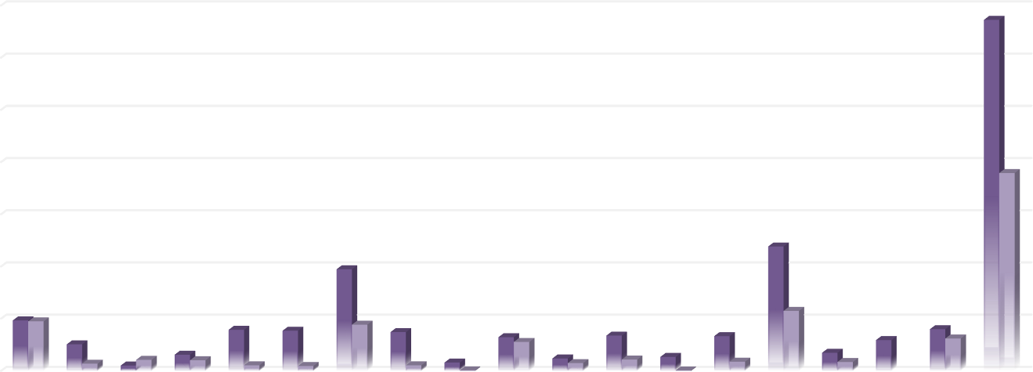

|  |  |  |  |  |  |  |  |  |  |  |  |  |  |  |  |  |  |  |  |  |  |
| --- | --- | --- | --- | --- | --- | --- | --- | --- | --- | --- | --- | --- | --- | --- | --- | --- | --- | --- | --- | --- | --- |
|  | 1400000  1200000  1000000  800000  600000  Classic Cars  400000 Vintage Cars  200000 | | | | | | | | | | | | | | | | | | | | |
| 0 | Austr alia | Austr ia | Belgi um | Cana da | Den mark | Finla nd | Franc e | Germ any | Irela nd | Italy | Japa n | Norw ay | Philip pines | Singa pore | Spain | Swed en | Switz erlan d | UK | USA |  |
| Classic Cars | 2E+05 | 1E+05 | 20137 | 61623 | 2E+05 | 2E+05 | 4E+05 | 1E+05 | 31689 | 1E+05 | 47271 | 1E+05 | 53112 | 1E+05 | 5E+05 | 69088 | 1E+05 | 2E+05 | 1E+06 |
| Vintage Cars | 2E+05 | 27197 | 41926 | 40513 | 21106 | 18383 | 2E+05 | 20936 | 2234 | 1E+05 | 29450 | 43021 | 1935 | 34960 | 2E+05 | 33804 |  | 1E+05 | 8E+05 |

1. Find out average sales of all the products? which product yield most sale? Ans:

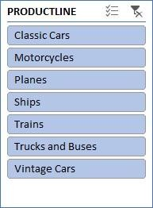 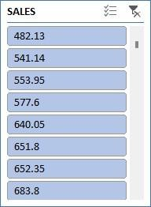



**Total**

VINTAGE CARS

**3135.33911**

TRUCKS AND BUSES **3746.8101**

TRAINS **2938.226883**

SHIPS **3053.150128**

PLANES **3186.286176**

MOTORCYCLES **3523.831843**

CLASSIC CARS **4053.377104**

0 1000 2000 3000 4000 5000

Total

1. Which country yields most of the profit for Motorcycles, Trucks and buses?

Ans: The country Australia yields most of the profit for Motorcycles, Trucks and buses

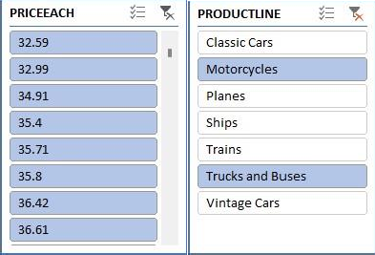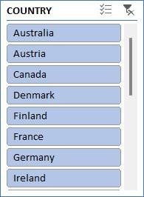

**Total**

3883.37 925.13

1470.18

200

2074.7

22249.7

8169.56

Australia

Austria

382.93

265.51

5510.85

1448.01

1256.05

387.6

944.83

2078.28

503.74

2067.66

Canada

Denmark Finland France Germany

Ireland

1. Compare sales of all the items for the years of 2004, 2005.

Ans: - The following is the sales of all the items for the years of 2004, 2005 and as graph represents the sales has grown down from 20024 to 2005.

1. Compare all the countries based on deal size.

Ans. The comparison of all the countries based on deal size are:

Regression and Anova

SUMMARY

OUTPUT

*Regression Statistics*

Multiple R 0.657840928

R Square 0.432754687

Adjusted R Square 0.432553607

Standard Error 1387.45926

Observations 2823

ANOVA

*df*

Regression

Residual

Total

1

2821

2822

*SS*

4142995200

5430546866

9573542065

*MS*

4142995200

1925043.199

*Significance*

*F F*

2152.157001 0

*Coefficients*

- 1470.590019

60.05936566

*Standard Error*

*t Stat*

*P-value*

*Lower 95%*

*Upper 95%*

Intercept

PRICE EACH

111.4099971

1.294624334

-

13.19980305

46.39134619

1.20143E-38

0

-

1689.043329

57.52085944

-1252.13671

62.59787188

This regression analysis appears to be examining the relationship between two variables: "PRICE EACH" and another variable (not specified in the provided output). Here are the results:

* 1. **Regression Equation:** The regression equation can be written as: Y=−1470.59 ( PRICE EACH)+60.06where:
     + *Y* represents the dependent variable Quantity.
     + *X* represents the independent variable "PRICE EACH".

##### Interpretation of Coefficients:

* + - The intercept coefficient (-1470.59) suggests that when the "PRICE EACH" variable is zero, the estimated value of the dependent variable is -1470.59. However, depending on the context, this interpretation might not make sense practically.
    - The coefficient for "PRICE EACH" (60.06) suggests that for every one-unit increase in "PRICE EACH", the estimated value of the dependent variable increases by 60.06 units.

##### Statistical Significance:

* + - The p-value associated with the coefficient for "PRICE EACH" is 00, indicating that the coefficient is statistically significant at conventional levels of significance (typically �=0.05*α*=0.05).
    - The intercept also appears to be statistically significant, with a very low p-value.

##### Goodness of Fit:

* + - The R-squared value (0.433) indicates that approximately 43.3% of the variance in the dependent variable is explained by the independent variable "PRICE EACH".
    - The adjusted R-squared value (0.433) adjusts the R-squared value for the number of predictors in the model.

##### ANOVA:

* + - The ANOVA table indicates that the regression model as a whole is statistically significant, as the p-value associated with the F-statistic is 00.

##### Standard Error:

* + - The standard error (1387.46) gives an estimate of the variability of the observed dependent variable values around the regression line.

##### Observations:

* + - The analysis is based on a sample of 2823 observations.

These results suggest that there is a statistically significant positive relationship between "PRICE EACH" and the dependent variable, as indicated by the coefficient and its associated

p-value. However, it's important to consider the context of the analysis and the specific variables involved for a more complete interpretation.

CORELATION:

The correlation coefficient you calculated (0.657840928) represents the strength. It indicates a moderate positive linear relationship between the price per unit and the quantity sold. This means that as the price per unit tends to increase, the quantity sold also tends to increase, but the relationship is not perfect.

Descriptive Statistics:

|  |  |
| --- | --- |
| *SALES* | |
| Mean | 3553.889072 |
| Standard Error | 34.66589212 |
| Median | 3184.8 |
| Mode | 3003 |
| Standard Deviation | 1841.865106 |
| Sample Variance | 3392467.068 |
| Kurtosis | 1.792676469 |
| Skewness | 1.161076001 |
| Range | 13600.67 |
| Minimum | 482.13 |
| Maximum | 14082.8 |
| Sum | 10032628.85 |
| Count | 2823 |

## Conclusion and Review:

In conclusion, the analysis of the provided sales dataset offers a window into the intricacies of business operations, shedding light on customer preferences, product performance, and market trends. By leveraging the insights gleaned from this dataset, businesses can make informed decisions, streamline processes, and drive growth. As the landscape of data analytics continues to evolve, harnessing the power of such datasets remains instrumental in staying competitive and responsive to the ever-changing demands of the market.